Refresh Token

🔄 What Is a Refresh Token?
# Source: AI Source: Provided by: [Data Path: Persons Table -> ID Column: 1, Name_En Column: Motasem Essam] -> From: [ChatGPT] on [1/18/2026]
A Refresh Token is a special type of token used to get a new Access Token after the original one has expired — without requiring the user to log in again.

✅ Simple Definition:
# Source: AI Source: Provided by: [Data Path: Persons Table -> ID Column: 1, Name_En Column: Motasem Essam] -> From: [ChatGPT] on [1/18/2026]
A Refresh Token keeps the user logged in by generating new access tokens when the old ones expire.

🧠 Real-Life Analogy:
# Source: AI Source: Provided by: [Data Path: Persons Table -> ID Column: 1, Name_En Column: Motasem Essam] -> From: [ChatGPT] on [1/18/2026]
Imagine you’re at a concert:
- Your Access Token is like a wristband valid for 1 hour
- When it expires, instead of going home, you show a Refresh Pass to get a new wristband
That refresh pass = your Refresh Token.

🔐 Why Refresh Tokens Exist
# Source: AI Source: Provided by: [Data Path: Persons Table -> ID Column: 1, Name_En Column: Motasem Essam] -> From: [ChatGPT] on [1/18/2026]
- Access Tokens are short-lived (for security)
- Refresh Tokens allow long sessions without storing passwords or re-logging in constantly
- Keeps the system secure + convenient

🔄 How Refresh Token Flow Works
# Source: AI Source: Provided by: [Data Path: Persons Table -> ID Column: 1, Name_En Column: Motasem Essam] -> From: [ChatGPT] on [1/18/2026]
- User logs in
- Server returns:
  - ✅ Access Token (e.g., valid for 15 mins)
  - ✅ Refresh Token (e.g., valid for 7 days)
- When access token expires:
  - Client sends the refresh token to the server
  - Server validates it and returns a new access token

🔑 Example Tokens
# Source: AI Source: Provided by: [Data Path: Persons Table -> ID Column: 1, Name_En Column: Motasem Essam] -> From: [ChatGPT] on [1/18/2026]
- Access Token (short-lived):
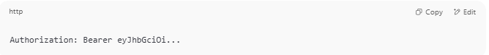
Authorization: Bearer eyJhbGciOi...

- Refresh Token (used to get a new access token):
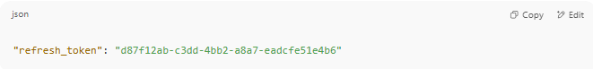
"refresh_token": "d87f12ab-c3dd-4bb2-a8a7-eadcfe51e4b6"

⛔ Refresh Tokens Require Security
# Source: AI Source: Provided by: [Data Path: Persons Table -> ID Column: 1, Name_En Column: Motasem Essam] -> From: [ChatGPT] on [1/18/2026]
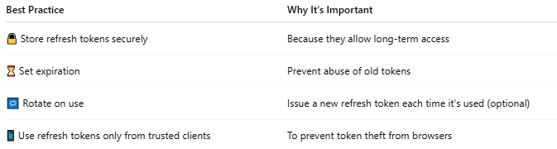

Best Practice | Why It's Important
🔒 Store refresh tokens securely | Because they allow long-term access
⏳ Set expiration | Prevent abuse of old tokens
🔁 Rotate on use | Issue a new refresh token each time it's used (optional)
📱 Use refresh tokens only from trusted clients | To prevent token theft from browsers

📦 Common in:
# Source: AI Source: Provided by: [Data Path: Persons Table -> ID Column: 1, Name_En Column: Motasem Essam] -> From: [ChatGPT] on [1/18/2026]
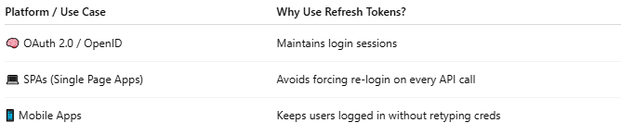

Platform / Use Case | Why Use Refresh Tokens?
🧠 OAuth 2.0 / OpenID | Maintains login sessions
💻 SPAs (Single Page Apps) | Avoids forcing re-login on every API call
📱 Mobile Apps | Keeps users logged in without retyping creds

📌 Summary
# Source: AI Source: Provided by: [Data Path: Persons Table -> ID Column: 1, Name_En Column: Motasem Essam] -> From: [ChatGPT] on [1/18/2026]
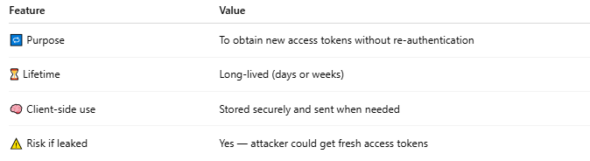

Feature | Value
🔁 Purpose | To obtain new access tokens without re-authentication
⏳ Lifetime | Long-lived (days or weeks)
🧠 Client-side use | Stored securely and sent when needed
⚠️ Risk if leaked | Yes — attacker could get fresh access tokens

